Valley Vettes, Inc.
MEMBERSHIP APPLICATION/RENEWAL FORM
Member #_______________(office use field) Date:_______________
Single or Dual Membership

Name: ________________________________________Name on Badge: ______________
Date of Birth: (Optional) Month/Day: _______/_______
Name: ________________________________________Name on Badge: ______________
Date of Birth: (Optional) Month/Day: _______/_______
Address:_____________________________________________________
City: ___________________________ State: _________ Zip code: ______________
Home Phone: ____________________________________
Cell Phone:________________________________________
Cell Phone:________________________________________
E-Mail: __________________________________________
E-Mail: __________________________________________
Wedding Anniversary (Optional): Month/Day: _______/_______
Tell us a little about yourselves: Where from, hobbies, sports, home town, anything you wish to share with our members: _________________________________________________________________________
____________________________________________________________________________________
____________________________________________________________________________________
____________________________________________________________________________________
____________________________________________________________________________________

Corvette Information
Year: __________ Color: __________________ Body Style: _____________________________
Year: __________ Color: __________________ Body Style: _____________________________
Year: __________ Color: __________________ Body Style: _____________________________
Year: __________ Color: __________________ Body Style: _____________________________
Year: __________ Color: __________________ Body Style: _____________________________
Year: __________ Color: __________________ Body Style: _____________________________
Year: __________ Color: __________________ Body Style: _____________________________
Membership Fees
Single New Member: $62.00 First year includes a New Member Package & Name Badge
Dual New Member: $74.00 First year includes a New Member Package & 2 Name Badges
First Year: on/after October 1st: $42 single or $54 dual including name badges.
Note: Badges utilize magnetic fasteners and typically display First Name only.
Membership Renewal: $45.00 For Single or Dual membership.
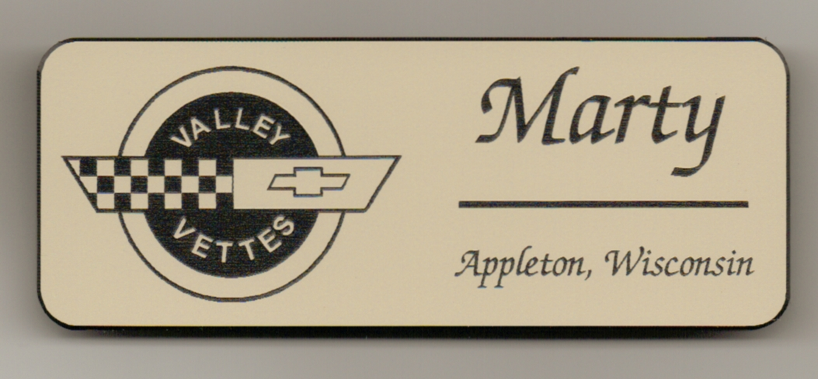

Please make checks payable to: Valley Vettes
P O Box 2555
Appleton, WI 54912-2555

